**HOW TO ATTACH DOCUMENT TO AN APPOINTMENT  (if the document is already saved in repository):**

1. Go into the patients chart
2. Go into the Document Repository
3. Find the document that is not attached to the appointment
4. Right click on the document in the Documents on File window. Select ‘Change Document Settings’

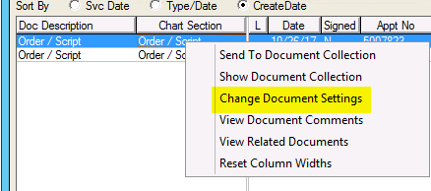

1. The Change Document Settings window will appear, and the Appt No field will most likely be blank, or will be the wrong appointment number.
2. Click ‘Change Appt No’

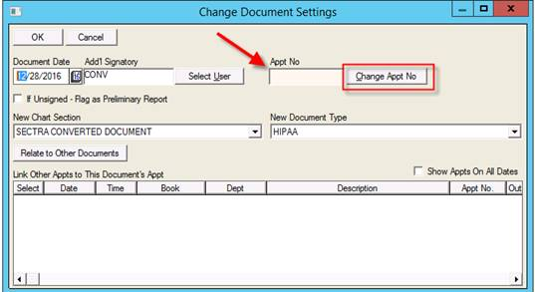

1. Highlight the appointment that the document correlates to, and click ‘Select’.
2. Click ‘OK’ in the Change Document Settings screen to save the changes

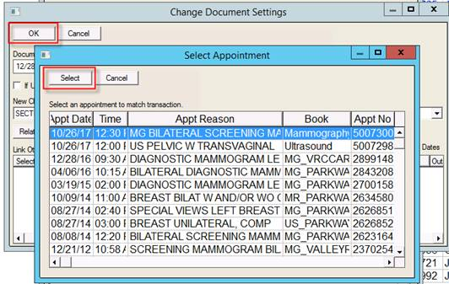

**HOW TO IMPORT DOCUMENTS INTO THE REPOSITORY (without printing and scanning):**

1. Go into the patients chart under the appointment you want to add the document to.
2. Go into the Document Repository
3. Click the ‘Import’ button at the top of the Repository toolbar

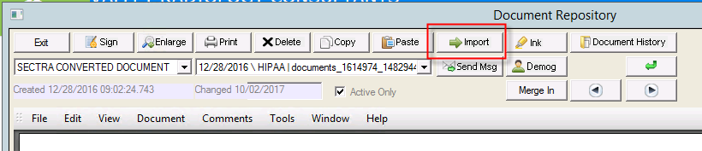

1. Highlight the name of the document you are importing, and click ‘Select’

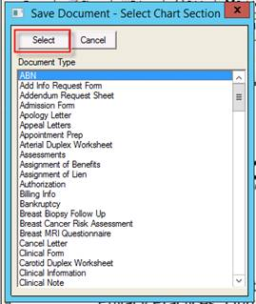

1. Navigate to where you saved the document. (i.e. if the document is saved on your desktop, then select desktop in the windows explorer screen). Find the document, and double click on it or click ‘Open’ at the bottom right.

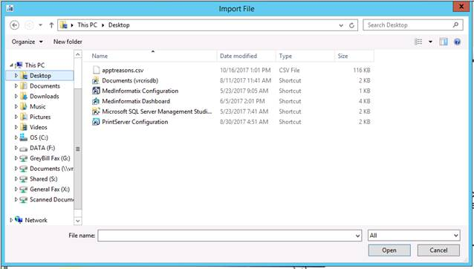

1. Click ‘Save’ to save the document

