MedInformatix Real-time Eligibility Inquiries
Getting to the Eligibility History screen
From Demographics:
- Click the “Edit Coverage” button for the desired payer.
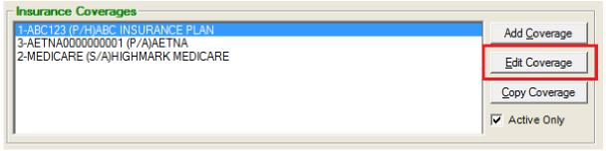
- Click the “Eligibility” button on the Insurance Coverage Screen:
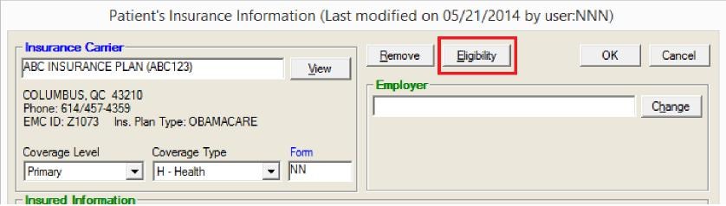
From the Master Appointment List:
1. Select the desired patient/appointment and click the “Ins Eligibility Check” button:
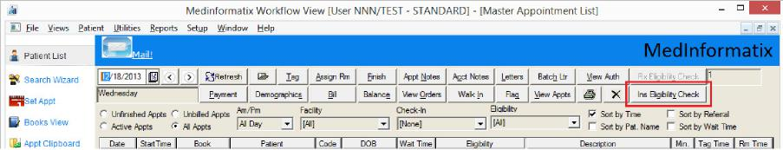
Working on the Eligibility History screen
This screen will show the inquiry history for the account. The “Status” column refers to the status of the inquiry – NOT the status of the patient. An “Active” status indicates that the eligibility response has not yet come back from ZirMed. An “Inactive” status indicates that the response from ZirMed has been received and is viewable in the lower portion of the screen.
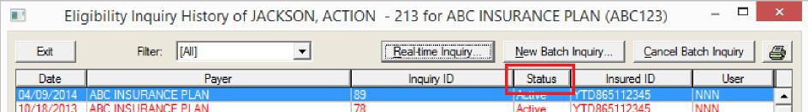

Working on the Eligibility History screen - continued
To submit a new inquiry:
- Click the “Real-time Inquiry” button on the Eligibility History screen:
- On the next screen, set the parameters accordingly and click OK. A browser window will open and the response will display within a few seconds. The Inquiry Service Type determines which benefit type you’re inquiring about; use 30 if you’re looking for general coverage information.
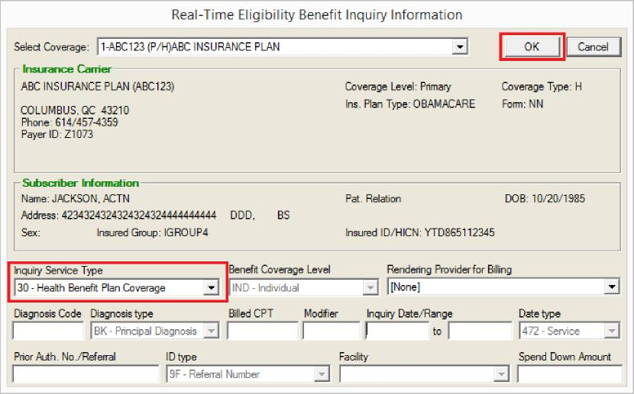
When a response comes back from ZirMed, it will populate the “Eligibility” column on the Master List as well as the Eligibility Verification Status field on the Patient’s Insurance Information screen:
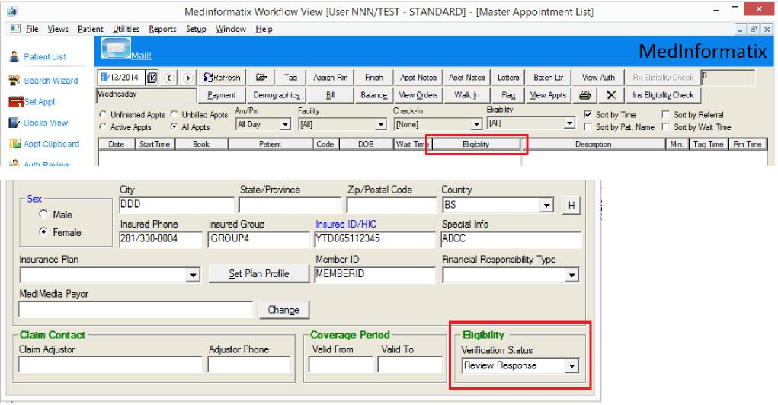

The response will then be viewable at the bottom of the Eligibility Inquiry History screen:

Eligibility Inquiry History of for MOLINA CENTENNIAL CARE (A39)

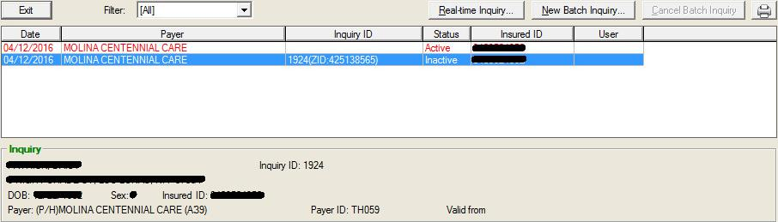
Inquiry ID: 1924
Inquiry
elompompor
Payer ID: TH059 Valid from
DOB: CEININIIR Sex:0 Insured ID:
(P/H)MOLINA CENTENNIAL CARE (A39)
Bt
Filter: I [Al]
Beal-time Inquiry...
New Batch Inquiry...
Cancel Batch Inquiry I I
Date
Payer
Inquiry ID
Status
Insured ID
User I
04/12/2016 MOLINA CENTENNIAL CARE
1924 ZID:425138565 Inactive _ _
04/12/2016 MOLINA CENTENNIAL CARE Active 1100111110111110
Response | Online Refresh I
Eligibility Response A
Inquiry ID: 425136356 Processed: 4/13/2016 2:25 PM
ACTIVE COVERAGE
Coverage Details
User Entered Information

Payer Molina Healthcare of New Mexico | Service Dates 04113/2016
SUBSCRIBER INFORMATION SERVICE TYPES REQUESTED
Member ID 4 - Diagnostic X-Ray

