Worklist and exam colors
Green: exam completed
Red: patient not arrived, past exam time
Blue: exam in progress, not completed
Black: patient scheduled, before exam time
Green Highlight: patient checked in and ready for tech
Red highlight: patient is marked STAT/ASAP
*at end of shift all patient should be green- exam completed. Red if patient missed appointment
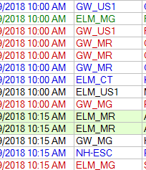
Workflow for MI
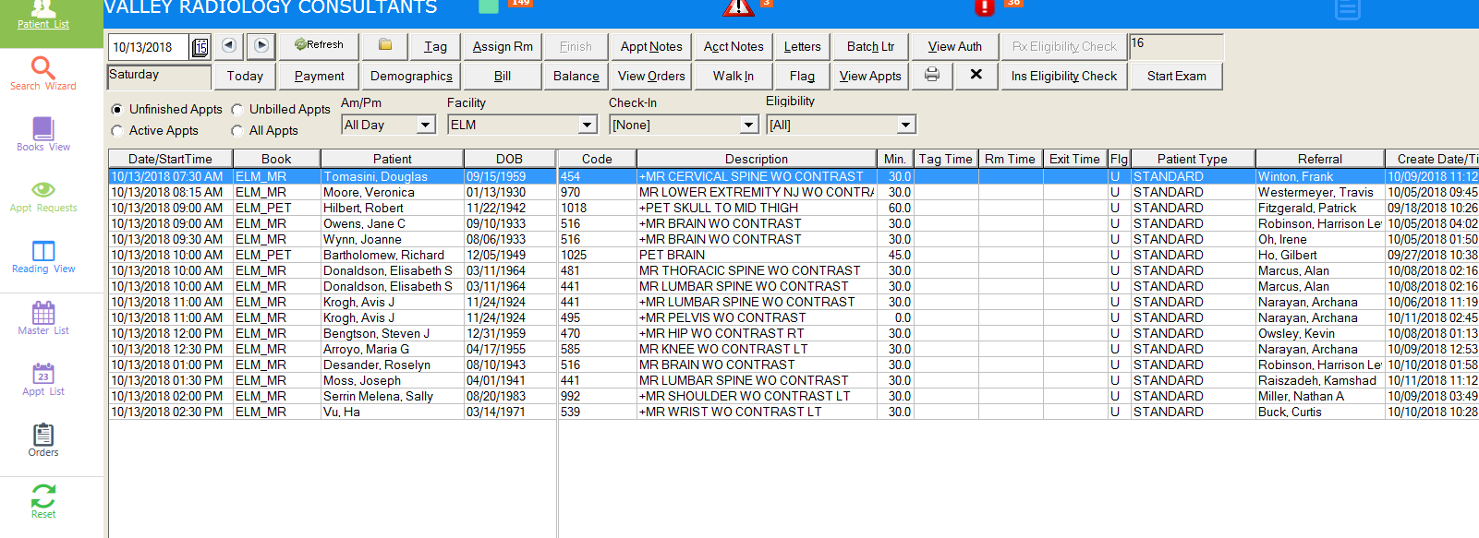
Start on master list. Unfinished appointments. High light patient and click on Start exam to begin the exam.
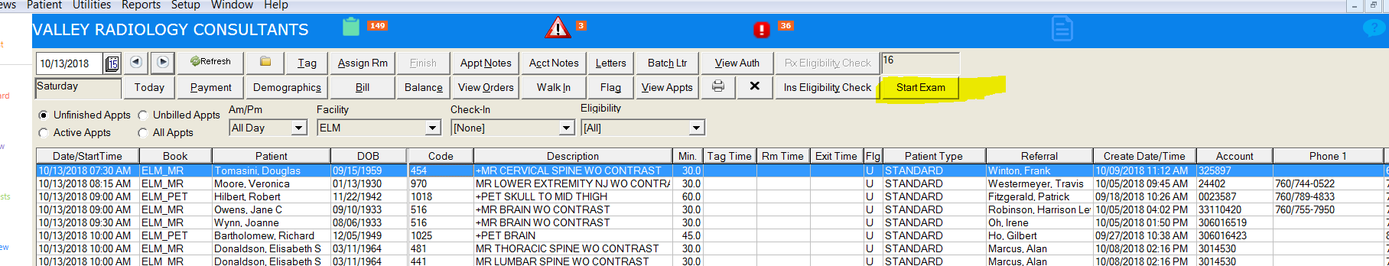

Double click on patient to open chart.
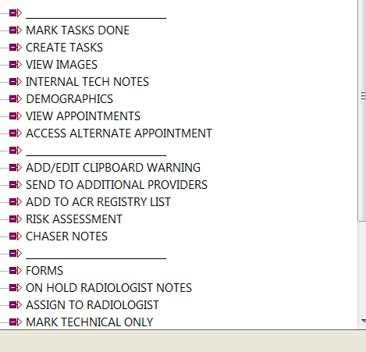
On technologist tree. Look at Internal tech notes, check chaser notes on chart or in tree. Chart will only show most recent notes, for full notes review chaser notes in tree.
Next, check order and the auth- need to match. Make sure its authorized for our site. Verify exam type. Note: During exam/day of exam if patient refuses contrast notify chaser. (auth/CPT code may need to be updated.)
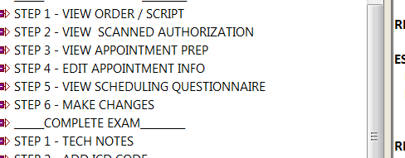

Now, verify the scheduling questionnaire. Look for height and weight, and any possible internal implants or surgeries.
Once complete- bring patient back from waiting room. Confirm patient identity with 2 patient identifiers to ensure it is the correct patient.
Confirm patient questionnaire with patient and review any safety related opportunities. Complete any exam prep that is needed to prepare patient for exam. Once exam has started, here are the steps needed to complete the patient in MI.

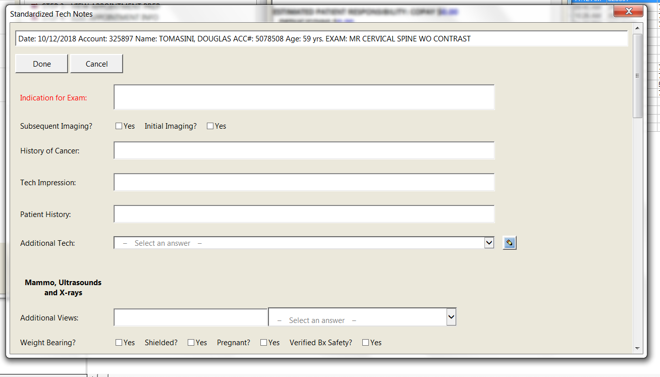
Click on step 1- Tech notes- these appear on the report. Clear, concise and accurately spelled out. Start with “Indication for exam”. Word version of diagnosis from order and pertinent history, and prior exams.
Instructions for data entry:
Indications for exam: First sentence should be what the doctor has put on the order and/or the translated version of the ICD10 code. Second sentence should be a summary of the tech interview with patient that specifies the symptoms (e.g. Location, side duration, severity.) Also provide pertinent prior medical or subsequent encounter. {This information will automatically populate on report. Do not put information in this section that contradicts or otherwise would embarrass the referring physician.}
Tech Impression: input information about the quality of the exam (e.g. patient moved, uncooperative, contrast reaction, etc.)
Patient History: Put in whatever other information patient discloses about their medical history that doesn’t necessarily belong in the indications.
MRI: label all breast studies as ASAP unless marked STAT
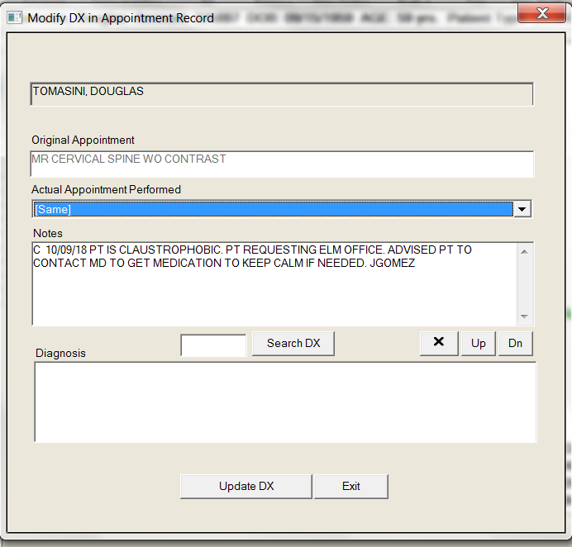

Step 2- “Add ICD 10” from tree- If you know ICD 10 number, enter in box. If you don’t know ICD, click on Search DX. Search form listed codes. This will add diagnosis to patient’s clipboard/ chart. Copy diagnosis and add on indication for exam.

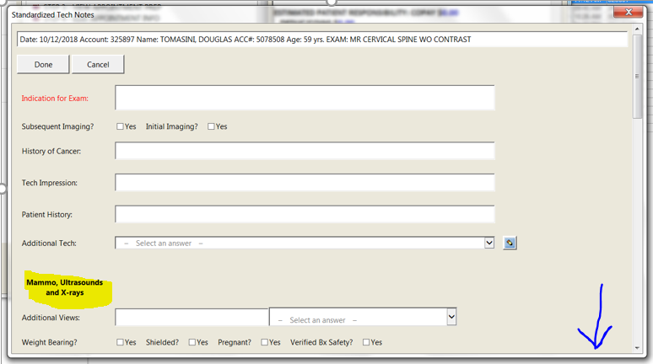

Go back to tech notes- enter in contrast information (if applicable), patient height and weight. Enter any other modality related questions. Scroll down to see other modalities.

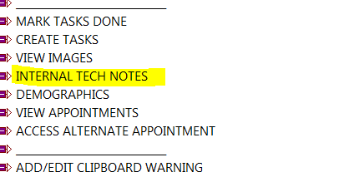

Use internal tech notes for any pertinent documentation regarding the patient’s chart and their exam. Technologist and radiologist information (notes are internal only and do not appear on report. Examples: patient unable to complete exam and why – patient is claustrophobic will return with meds. Patient in pain, only able to complete exam. Needs addition sequencing and why- and so forth.

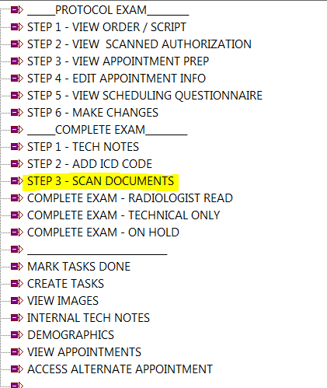
During or after patient exam. Documents related to the exam need to be scanned into the patient chart. Click on Step 3- scan documents. Click on the document that is being scanned and in and scan into chart. Patient safety questionnaire goes under worksheets. Separate tab for MRI. Contrast goes under consented waiver.

View images and confirm that all images and sequences are ready to be sent over. Confirm order to ensure if exam is global or tech only. Once confirmed click on “complete exam- radiologist read”. For Tech Only: Click: Mark tech only and then click: “Complete Exam- Technical only”
Examples of this may be images for clinical trials that are uploaded to a third-party site or a group account like Dr. Schiffman. Refer to clinical trial protocol or order to determine is Global or technical.

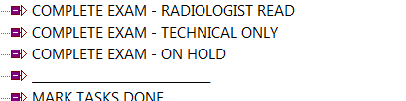

Mark appointment Done.

Patient Issues
If patient is claustrophobic, no show or unable to complete exam. Add notes in Internal tech notes. Then call referring physician to notify them. If patient is a no show, technologist calls patient to re-schedule.

